**Ideation Phase**

**Define the Problem Statements**

|  |  |
| --- | --- |
| Date | 19 September 2022 |
| Team ID | B7-1A3E |
| Project Name | Smart Waste Management System For Metropolitan Cities |
| Maximum Marks | 2 Marks |

**TEAM MEMBERS:**

HARIPRASATH_1905083

MEERADEVI_1905094

SANJAI_1905111

THENDRAL_1905119

**Customer Problem Statement** :

This project aims at developing an IOT based centralized module by using Ultrasonic sensors for effectively identifying the level of bio-degradable waste that are collected in various bins.

PROBLEM STATEMENT:1

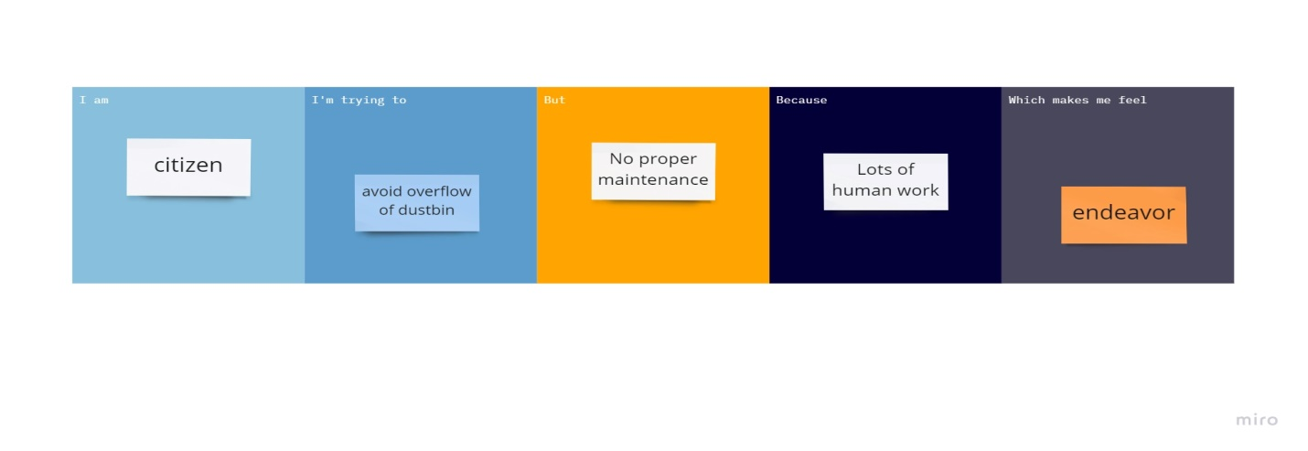

PROBLEM STATEMENT:2

